7.1.10 Editors - 3D View - Header - Mesh - Edit Mode - Vertex Menu
Detailed Table of content 1
Edit Mode - Vertex Menu 4
Bevel Vertices 4
Make Edge/Face 6
Connect Vertex Path 7
Connect Vertex Pair 7
Rip Vertices 7
Rip Vertices and Fill 8
Rip Vertices and Extend 8
Slide Vertices 9
Smooth Vertex 10
Smooth Laplacian 10
Merge Vertices 11
By Distance 12
Vertex Groups 12
Hooks 13
Make Vertex Parent 15

Detailed Table of content

Detailed table of content
Detailed Table of content 1
Edit Mode - Vertex Menu 4
Bevel Vertices 4
Last Operator Bevel 4
Width type 4
Width 4
Segments 4
Profile 4
Vertex only 5
Clamp Overlap 5
Loop Slide 5
Mark Seams 5
Mark Sharp 5
Material 5
Harden Normals 5
Face Strength Mode 5
None 5
New 5
Affected 5
All 5
Outer Miter 5
Sharp 6
Patch 6
Arc 6
Inner Miter 6
Sharp 6
Arc 6
Spread 6
New Edge/Face from Vertices 6
Connect Vertex Path 7
Connect Vertex Pair 7
Rip Vertices 7
Last Operator Rip 7
Move X , Y , Z 7
Constraint Axis 7
Orientation 8
Proportional editing 8
Proportional Falloff 8
Proportional Size 8
Connected 8
Projected(2D) 8
Rip Vertices and Fill 8
Last Operator Rip Fill 8
Rip Vertices and Extend 8
Last Operator Extend Vertices 9
Move X , Y , Z 9
Constraint Axis 9
Orientation 9
Proportional editing 9
Proportional Falloff 9
Proportional Size 9
Connected 9
Projected(2D) 9
Slide Vertices 9
Smooth Vertex 10
Last Operator Smooth Vertex 10
Smoothing 10
Repeat 10
Axis 10
Smooth Laplacian 10
Last Operator Laplacian Smooth Vertex 10
Number of Iterations 10
Lambda Factor 10
Lambda Factor in border 10
Smooth Axis 10
Preserve Volume 10
Blend from Shape 11
Last Operator Blend from Shape 11
Drop-down box 11
Blend edit box 11
Add 11
Propagate to Shapes 11
Merge Vertices 11
At First 11
At Last 11
At Center 11
At Cursor 11
Collapse 11
Last Operator Merge 12
Type 12
UV's 12
By Distance 12
Last Operator Merge by Distance 12
Merge Distance 12
Unselected 12
Vertex Groups 12
Assign to New Group 12
Assign to active Group 13
Remove from Active Group 13
Remove from All 13
Set Active Group 13
Remove Active Group 13
Remove All Groups 13
Hooks 13
Hook to New Object 14
Hook to Selected Object 14
Last Operator Hook to Selected Object 14
Active Bone 14
Hook to Selected Object Bone 14
Assign to Hook 14
Remove Hook 14
Select Hook 14
Reset Hook 14
Recenter Hook 14
Make Vertex Parent 15
Workflow: 15

Edit Mode - Vertex Menu

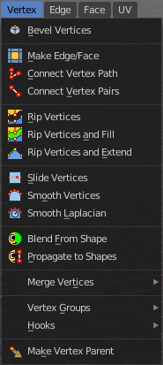
The Vertex menu just exists for mesh objects. It provides you with tools that are designed to modify vertices.

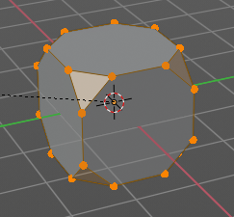
Bevel Vertices
The Bevel Tool adds a bevel to the selected vertices.
Usage: first select the geometry that you want to bevel. Then activate the tool and drag the mouse. You need to drag quite a bit outwards until you see an effect. So don't wonder when the mouse movement seem to do nothing. You can also adjust the amount in the Last Operator Bevel panel afterwards.
In the footer you can see further advice. And the current values for the bevel.

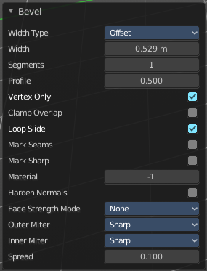
Last Operator Bevel

Width type
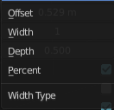
Width Type is a drop-down box where you can choose the Amount type for the bevel action.

Width
The Bevel amount.

Segments
How many segments gets created

Profile
Controls the Profile shape. 0.5 means round.

Vertex only
Bevel Vertices only.

Clamp Overlap
Do not allow bevelled geometry to overlap each other.

Loop Slide
Prefer slide along edge to even widths.

Mark Seams
Mark seams along the beveled edges.

Mark Sharp
Mark the beveled edges sharp.

Material
Material for bevelled faces. -1 is the surrounding material.

Harden Normals
Match the normals of the new faces to the adjacent faces.

Face Strength Mode
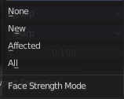
Face Strength Mode can be used in conjunction with Weight Normals Modifier (with the 'Face Influence' option checked). Here you can set if and howthe face strength at creation gets set.

None
Don't set face strength.

New
Set the face strength of new faces along edges to Medium. And the face strength of new edges at vertices to Weak.

Affected
In addition to those set for the New case, also set the faces adjacent to new faces to have strength Strong.

All
In addition to those set for the Affected case, also set all the rest of the faces of the model to have strength Strong.

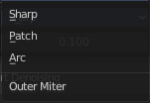
Outer Miter
How the outer miter is set. Miter is how the bevel rounding at a corner is done.


Sharp
Creates a sharp miter.


Patch
This replaces the outside vertex of a miter with 3 vertices. And uses a patch pattern there.

Arc

This replaces the vertex of a miter with 2 vertices, joined by an arc. A separate Spread parameter says how far to move the vertices away from their original position.

Inner Miter
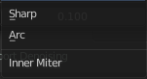
How the inner miter is set. Miter is how the bevel rounding at a corner is done.

Sharp
Creates a sharp miter.

Arc
This replaces the vertex of a miter with 2 vertices, joined by an arc. A separate Spread parameter says how far to move the vertices away from their original position.

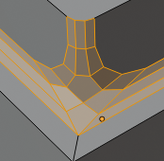
Spread
Belongs to inner miter method Arc. Here you can adjust how strong the inner radius is bent.

Make Edge/Face
Adds a face when you have edges selected. And Edges when you have Vertices selected. It's a Bridge tool.
You can have either the one method or the other. When you select two adjacent vertices, then you select the edge too. And the tool works in edge mode then. In this case just the possible faces gets created. Not edges between single vertices.
First select the edges or Vertices that you want to bridge. Then click the New Edge/Face from Vertices Button.
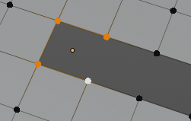
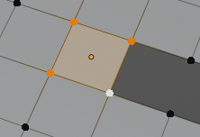
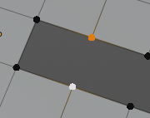
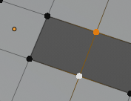

Connect Vertex Path
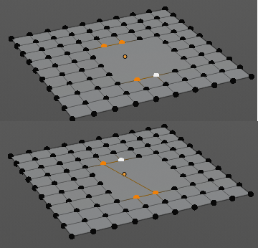
Connect Vertex path connects selected vertices, but takes the vertex order into account in which you selected the vertices. It just creates edges between vertices that are not connected in this order.

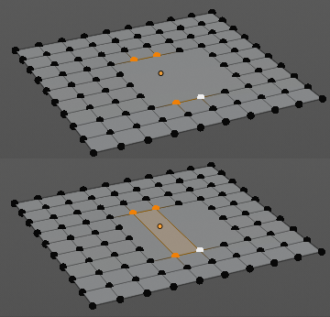
Connect Vertex Pair
Connect Vertex pair connects selected vertices and makes a face of the pairs.

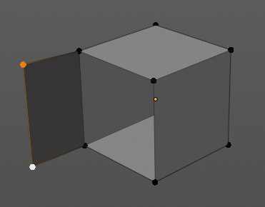
Rip Vertices
Rip splits the edges between the selected vertices. It creates two edges out of one.
This tool works similar to the Edge Split tool. It also selects the outer edges so that you immediately move them. Right click will snap them back to the initial space.

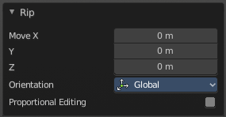
Last Operator Rip

Move X , Y , Z
Here you can adjust the position.


Constraint Axis
Here you can limit the position relative to the source object.

Orientation
Orientation is a drop-down box where you can choose the type of orientation for the mirroring action.

Proportional editing

Enables proportional editing. Activating proportional editing reveals further settings.

Proportional Falloff
Here you can adjust the falloff methods.

Proportional Size
Here you can see and adjust the falloff radius.

Connected
The proportional falloff gets calculated for connected parts only.

Projected(2D)
The proportional falloff gets calculated in the screen space. Depth doesn't play a role. When it's in the radius, then it gets calculated.

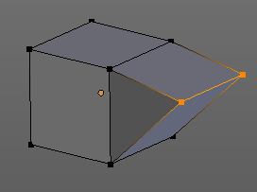
Rip Vertices and Fill
This tool works similar to the Rip tool. It splits the edges between the selected vertices. It creates two edges out of one. But it fills the gap between the new edges when you move the geometry.
This tool works similar to the Edge Split tool. It also selects the outer edges so that you immediately move them. Right click will snap them back to the initial space.

Last Operator Rip Fill
It is the same than for Rip Vertices.

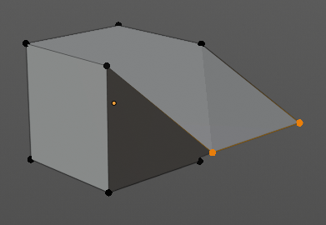
Rip Vertices and Extend
This tool extrudes the selected vertices.
This tool works similar to the Edge Split tool. It also selects the outer edges so that you immediately move them. Right click will snap them back to the initial space.

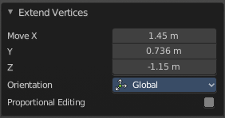
Last Operator Extend Vertices

Move X , Y , Z
Here you can adjust the position.

Constraint Axis
Here you can limit the position relative to the source object.

Orientation
Orientation is a drop-down box where you can choose the type of orientation for the mirroring action.

Proportional editing
Enables proportional editing. Activating proportional editing reveals further settings.

Proportional Falloff
Here you can adjust the falloff methods.

Proportional Size
Here you can see and adjust the falloff radius.

Connected
The proportional falloff gets calculated for connected parts only.

Projected(2D)
The proportional falloff gets calculated in the screen space. Depth doesn't play a role. When it's in the radius, then it gets calculated.

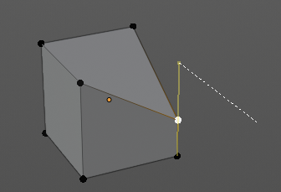
Slide Vertices
Slides the selected vertice(s) along the adjacent edges.

Smooth Vertex
Smooth Vertices smooths out the angles between the selected vertices. It is a tool to reduce noise at the mesh.

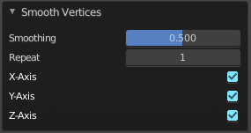
Last Operator Smooth Vertex

Smoothing
Smoothing is the strength of the smoothing

Repeat
Repeat is the number of iterations that the smoothing action gets repeated. With 1 the smoothing is just performed once. With 10 it is performed ten times.

Axis
The Axis checkboxes lets you limit the smoothing to specific world axis.

Smooth Laplacian
Laplacian Smooth Vertex smooths out the angles between the selected vertices. It is a tool to reduce noise at the mesh. It works a bit different than the normal Smooth Vertex tool. And gives a different result. The Laplacian method allows you to preserve the volume, and to adjust border smoothing.

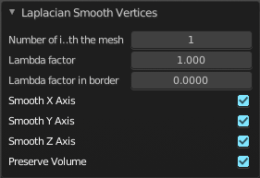
Last Operator Laplacian Smooth Vertex

Number of Iterations
Number of Iterations is the number of iterations that the smoothing action gets repeated. With 1 the smoothing is just performed once. With 10 it is performed ten times.

Lambda Factor
Lambda Factor is the strength of the smoothing.

Lambda Factor in border
Lambda Factor is the strength of the smoothing in border areas.

Smooth Axis
The Smooth Axis checkboxes allows you to limit the smoothing to specific world axis.

Preserve Volume
Preserve Volume preserves the volume of the object.

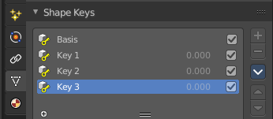
Blend from Shape
This tool requires to have a shape key at the mesh. It blends the selected shape key into the mesh.

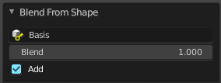
Last Operator Blend from Shape

Drop-down box
Here you can define which shape key should be used.

Blend edit box
Here you can adjust the blend factor between the current shape and the shape that you want to blend here.

Add
Add to blend shape instead of blending in.

Propagate to Shapes
This tool requires to have a shape key at the mesh. It applies the current vertex locations for the selected vertices to all other shape keys at the mesh.

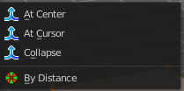
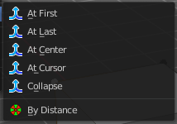
Merge Vertices
Merge vertices together. When you pick a vertice, and add more vertices to the selection, then you get two more tools, to merge to the first or last vertice. When you box select, or use select all, then you get just the other three tools.

At First
Merges the current selected vertices at the first selected vertice.

At Last
Merges the current selected vertices at the last selected vertice.

At Center
Merges the geometry at the centre of the selected vertices.

At Cursor
Merges the geometry at the 3D Cursor.

Collapse
Merges the geometry at the centre of the selected vertices.

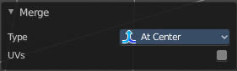
Last Operator Merge

Type
Type is the drop-down box again where you can choose what method to use for merge.

UV's
With UV's ticked the UV mapping will update with changes at the geometry.

By Distance
Merges vertices that are very close to each other. The merge happens at the center. When you need more control then you should use the Merge Vertices tool.

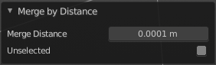
Last Operator Merge by Distance

Merge Distance
Here you can adusut the distance in which the vertices gets merged.

Unselected
Merge selected vertices also with other unselected vertices.

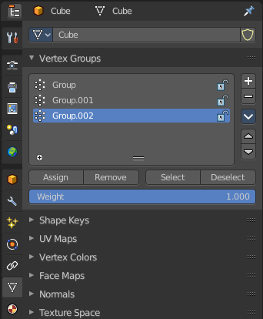
Vertex Groups
Vertex groups is a menu around vertex group functionality. The vertex groups can be found in the Object data tab in the Properties editor.
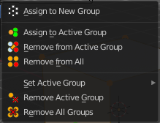

When there is no vertex group assigned yet then you can only see one menu item. The Assign To New Group button.
Once you have a vertex group assigned you will see the full functionality.

Assign to New Group
Assigns the mesh selection to a new vertex group.

Assign to active Group
Assigns the mesh selection to the currently active vertex group.

Remove from Active Group
Removes the mesh selection from the currently active vertex group.

Remove from All
Removes the mesh selection from all vertex groups.

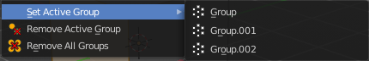
Set Active Group
Here you can select a vertex group to be the active one.

Remove Active Group
Removes the currently active vertex group.

Remove All Groups
Removes all vertex groups from the mesh.

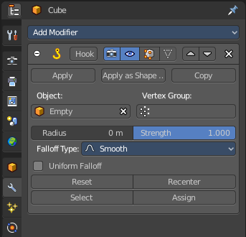
Hooks
Hooks is a menu with tools around the hook modifier. You could also adjust the hook modifier from the Properties editor. But the menu items are more accessible.
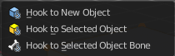
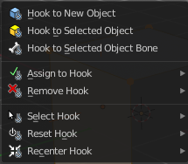

When there is no hook modifier at the mesh then you just see three menu items. When there is minimum one hook modifier applied, then you will see an extended menu.

Hook to New Object
Creates a new Hook Modifier for the active object and assigns it to the selected vertices. It also creates an empty at the center of those vertices, which are hooked to it.

Hook to Selected Object
Does the same as Hook to New Object, but instead of hooking the vertices to a new empty, it hooks them to the selected object (if it exists). There should be only one selected object (besides the mesh being edited).

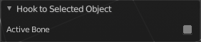
Last Operator Hook to Selected Object

Active Bone
Hook to the object(s) of the active bone.

Hook to Selected Object Bone
Does the same as Hook to New Object. But it sets the last selected bone in the also selected armature as a target.

Assign to Hook
Here you can assign the selected vertices to the chosen hook modifier. Existing hooks gets overwritten. One vertex can be assigned to more than one hook.

Remove Hook
Removes the chosen Hook Modifier from the object.

Select Hook
Selects all vertices assigned to the chosen Hook Modifier.

Reset Hook
Resets the chosen Hook Modifier.

Recenter Hook
Recenter the Hook Modifier.

Make Vertex Parent
Parents another object to the selected vertice(s).

Workflow:
In Object mode select the object that you want to parent to a vertex. Shift select the parent object so that both are selected. Enter Edit mode. Then select one vertex for a single point. Or three for an area. Then click the Make Vertex Parent button to make the relation.

